Time Taken: 10 mins

What you’ll need: 1 brain

Difficulty: Easy

We’ll be covering:

1. Parts of a Robot
2. System Diagram
3. Making your robot
4. Programming
5. Choosing components

**Parts of a Robot**

**There’s a little-known secret about robotics… All robots share the same basic components! If you can understand what they are, you can understand robotics!**

**Here’s what they are.**

1. **Sensors: Things that allow a robot to see the world**
2. **Actuators: Things that allow a robot to affect to world**
3. **Controller: The brain of a robot**
4. **Power supply: The energy source of a robot**
5. **Chassis: The body of the robot**
6. **Software: The behaviour of a robot.**

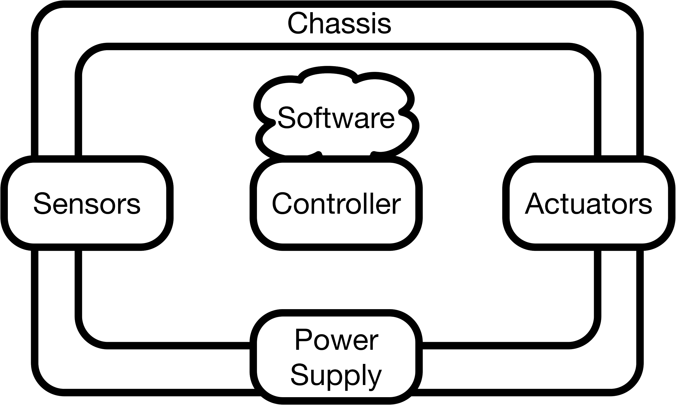

**All robots, no matter how simple or complex, will be made up of these parts. Choose the right components, design them to work together, and you’ve cracked robotics!**